**Name : J Viswaksena Roll.No : AM.EN.U4AIE21035**

**Given a sample document of ‘movie’ collection. Version: A**

{

_id: ObjectId("573a1390f29313caabcd42e8"),

plot: 'A group of bandits stage a brazen train hold-up, only to find a determined posse hot on their heels.',

genres: [ 'Short', 'Western' ],

runtime: 11,

cast: [

'A.C. Abadie',

"Gilbert M. 'Broncho Billy' Anderson",

'George Barnes',

'Justus D. Barnes'

],

poster: 'https://m.media-amazon.com/images/M/MV5BMTU3NjE5NzYtYTYyNS00MDVmLWIwYjgtMmYwYWIxZDYyNzU2XkEyXkFqcGdeQXVyNzQzNzQxNzI@._V1_SY1000_SX677_AL_.jpg',

title: 'The Great Train Robbery',

fullplot: "Among the earliest existing films in American cinema - notable as the first film that presented a narrative story to tell - it depicts a group of cowboy outlaws who hold up a train and rob the passengers. They are then pursued by a Sheriff's posse. Several scenes have color included - all hand tinted.",

languages: [ 'English' ],

released: ISODate("1903-12-01T00:00:00.000Z"),

directors: [ 'Edwin S. Porter' ],

rated: 'TV-G',

awards: { wins: 1, nominations: 0, text: '1 win.' },

lastupdated: '2015-08-13 00:27:59.177000000',

year: 1903,

imdb: { rating: 7.4, votes: 9847, id: 439 },

countries: [ 'USA' ],

type: 'movie',

tomatoes: {

viewer: { rating: 3.7, numReviews: 2559, meter: 75 },

fresh: 6,

critic: { rating: 7.6, numReviews: 6, meter: 100 },

rotten: 0,

lastUpdated: ISODate("2015-08-08T19:16:10.000Z")

}

.....

Inserted Movies

Movie-1

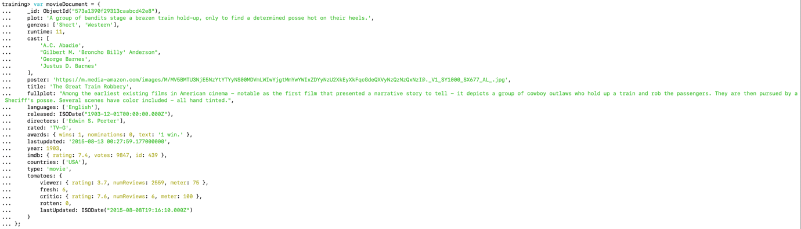

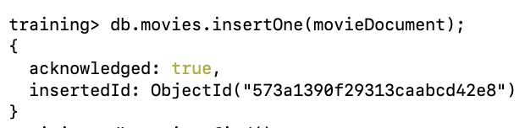

Movie-2

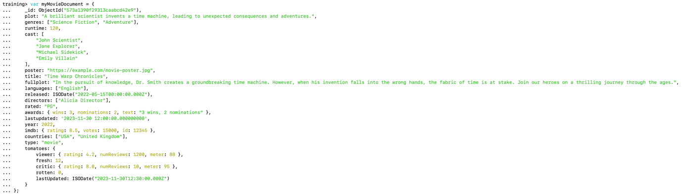

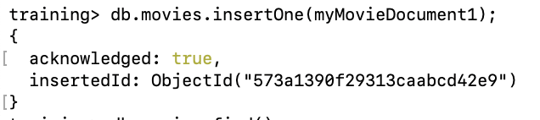

Movie-3

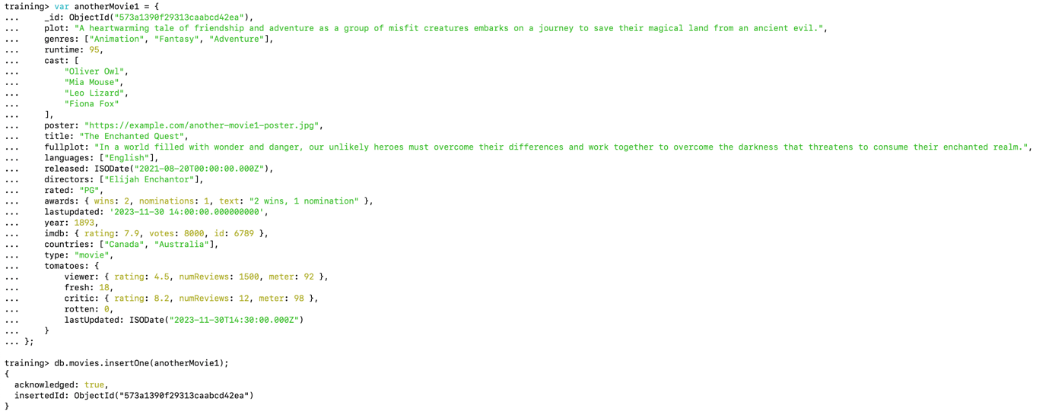

Movie-4

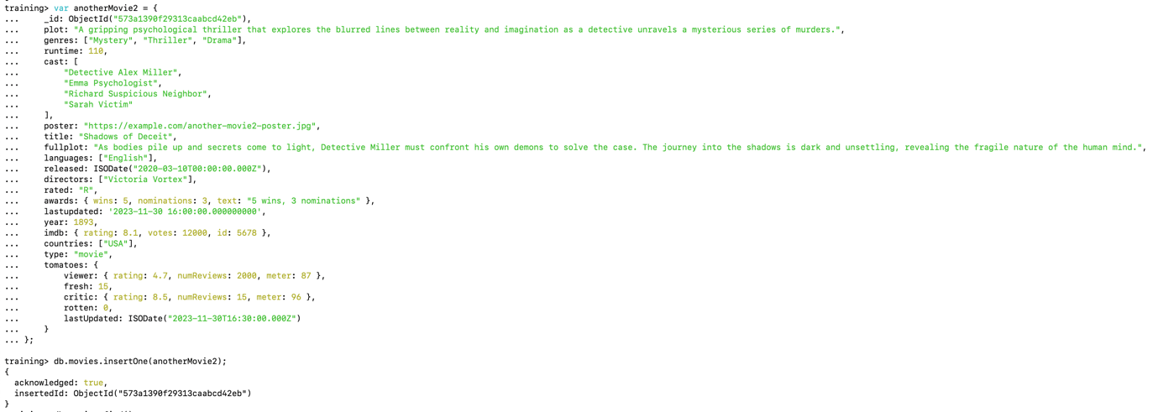

1. Find all movies with full information from the 'movies' collection that released in the year 1893.

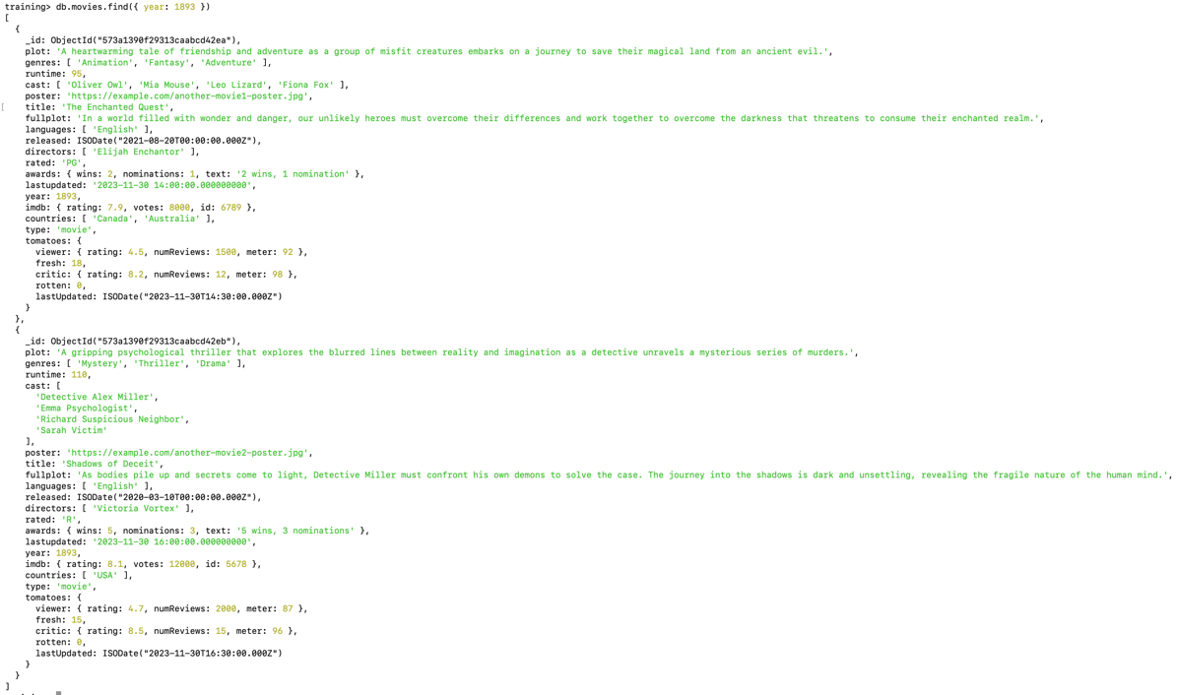

1. Find all movies with full information from the 'movies' collection that have a runtime greater than 120 minutes

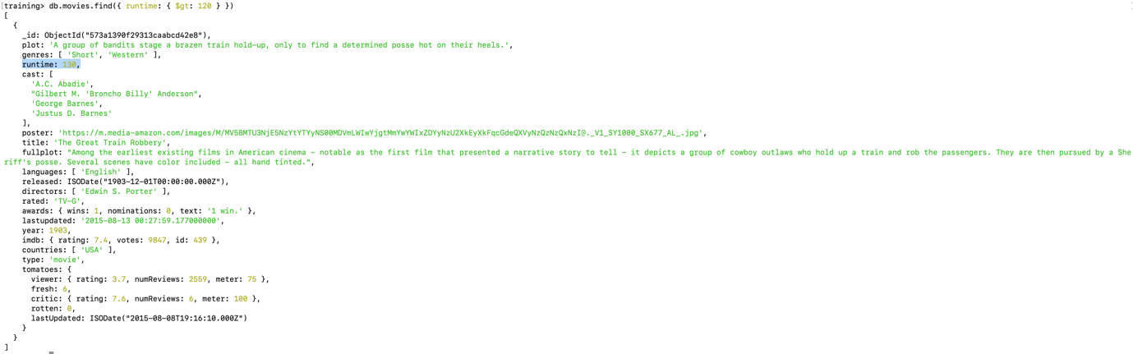

3.Find all movies with full information from the 'movies' collection that have "Short" genre.

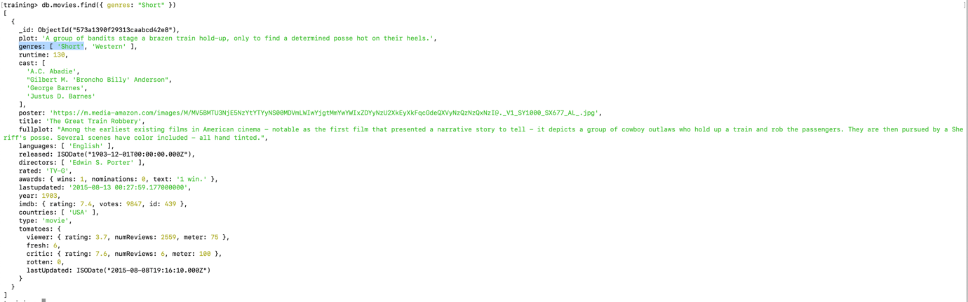

4.Retrieve all movies from the 'movies' collection that were directed by "William K.L. Dickson" and include complete information for each movie.

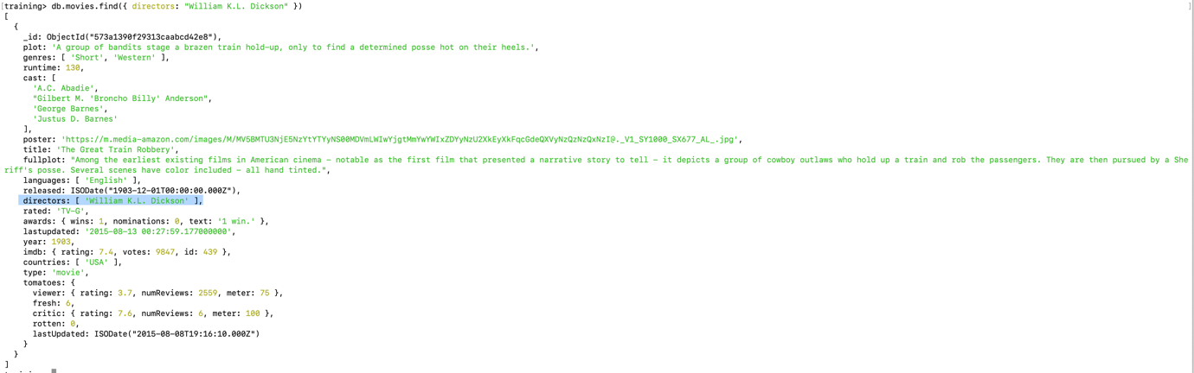

5. Retrieve all movies from the 'movies' collection that have complete information and are rated as "UNRATED".

